RESUME

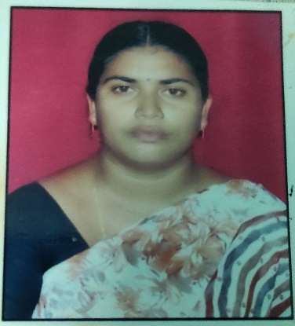

Mangalagiri.Prathibha Bharathi

**Email**: prathibhabarathi3011@gmail.com

Mobile: +91-7993034020, +91-9849434020

**Career Objective:**

➢ To purse a challenging carrier in a progressive environment while contributing to organizational

growth by way of dedicating skills and wills. Always interested and engaged in continual enhancement of information.

* Worked as a Telugu teacher for 10 years in GOOD NEWS HIGH SCHOOL.

**Brief Overview:**

* M.A B.ED(TELUGU) in Masters of Arts.
* Knowledge of Telugu .
* Abilities to handle multiple priorities with a genuine interest in professional and personal development.
* A self-motivated teacher with strong analytical, interpersonal and communication skills.

**Education:**

* M.A from Acharya Nagarjuna University,Gunturu,AP in 2013. Secured 257/500.
* B.ED from Acharya Nagarjuna University,Gunturu,AP in 2009. Secured 590/700.
* 12th from Maris Stella junior college, Vijayawada, Board of Intermediate, AP in 1999. Secured 453/500.
* 10th from Bishop Azariaiah T.M. High School, Vijayawada, SSC Board in 1996. Secured 336/600.

**Additional Skills:**

* Platforms : Teaching.
* Languages : Experienced 10 years in Telugu Teaching.

**Strengths:**

* Self Confidence, Nature of Accountability and Rule of Responsibility.
* Adaptive and positive Teacher.
* Courageous and self-motivated .

**Personal Details:**

Name : Mangalagiri .Prathibha Bharathi.

Date of Birth : 30-11-1980.

Gender : Female

Nationality : Indian

Languages known : English& Telugu.

Address : DNO: 32-23-7/1, ,csi school road,mogalrajpiram,Vijayawada,pincode – 520010.

**Declaration:** I hereby declare that above mentioned information is true to the best of my knowledge and belief.

Place: Date:

(M.Bharathi).